Lab 3 SQL injection by ammaruddin mohammed am3033

Part A

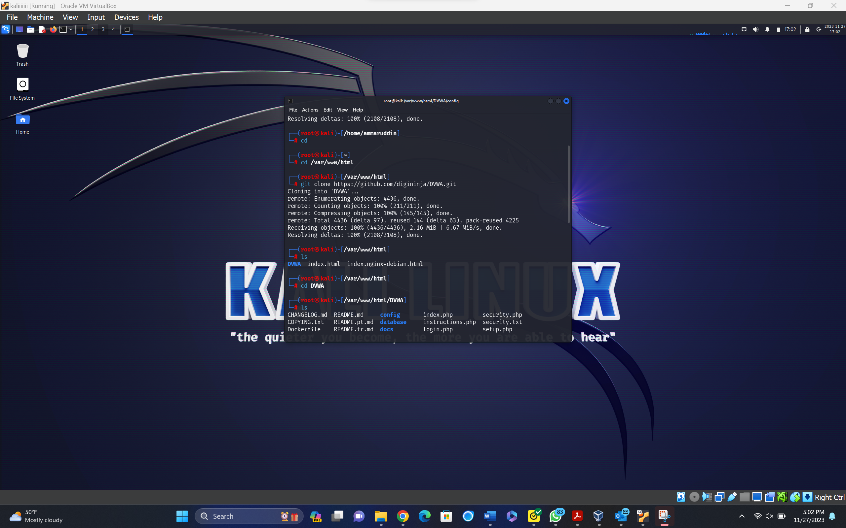

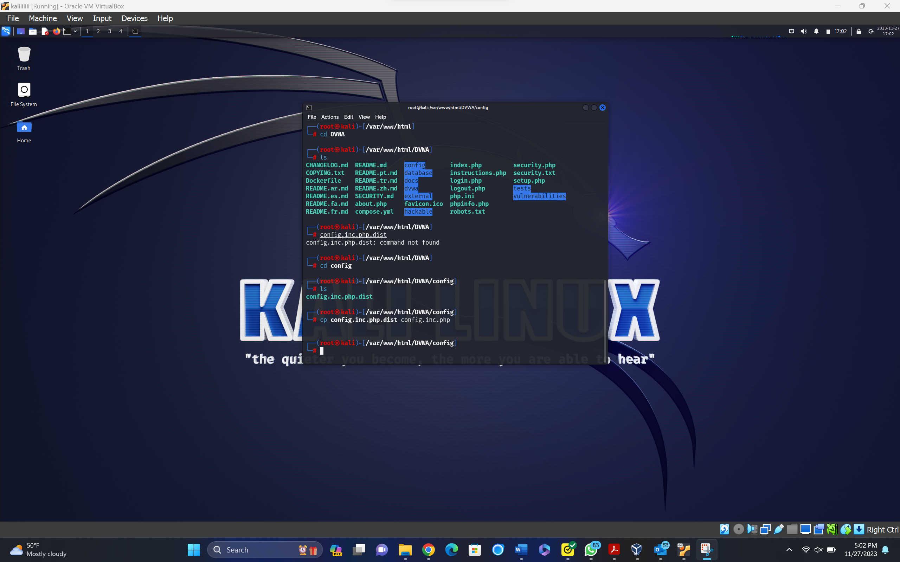

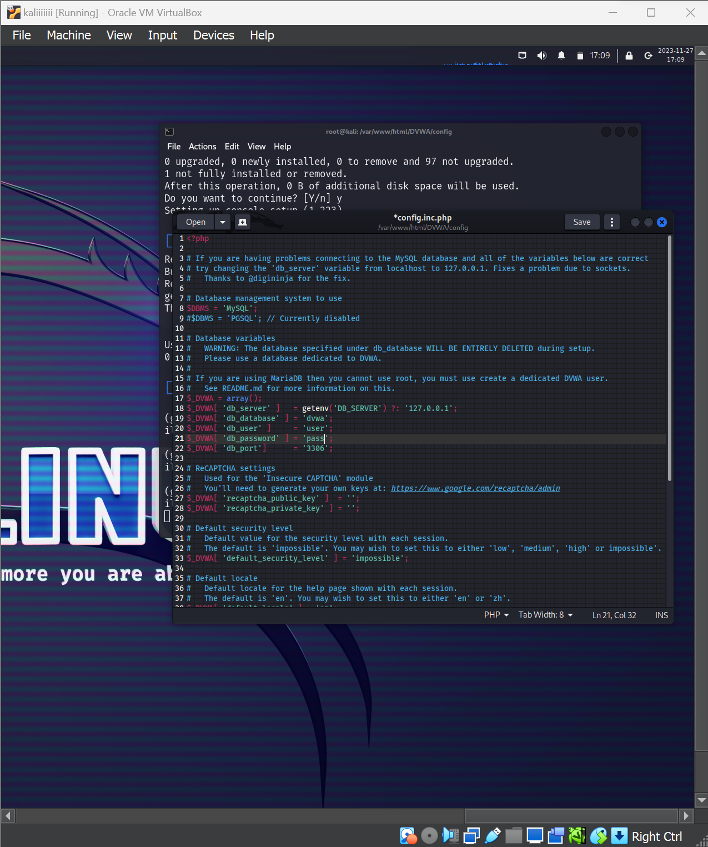

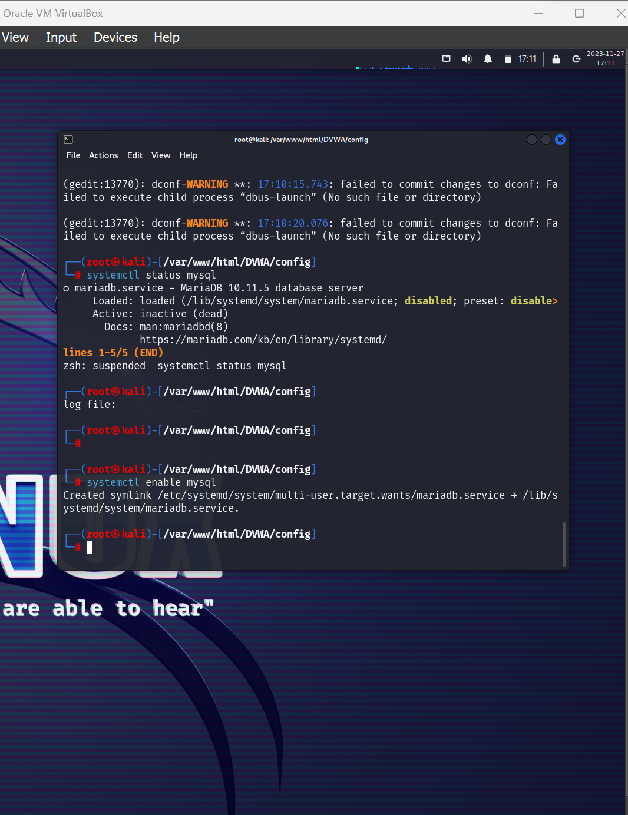

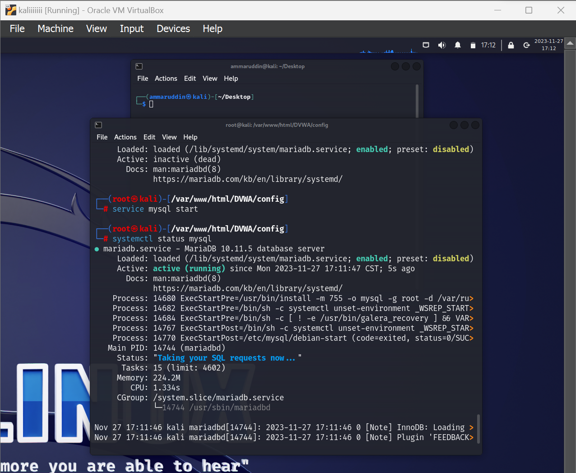

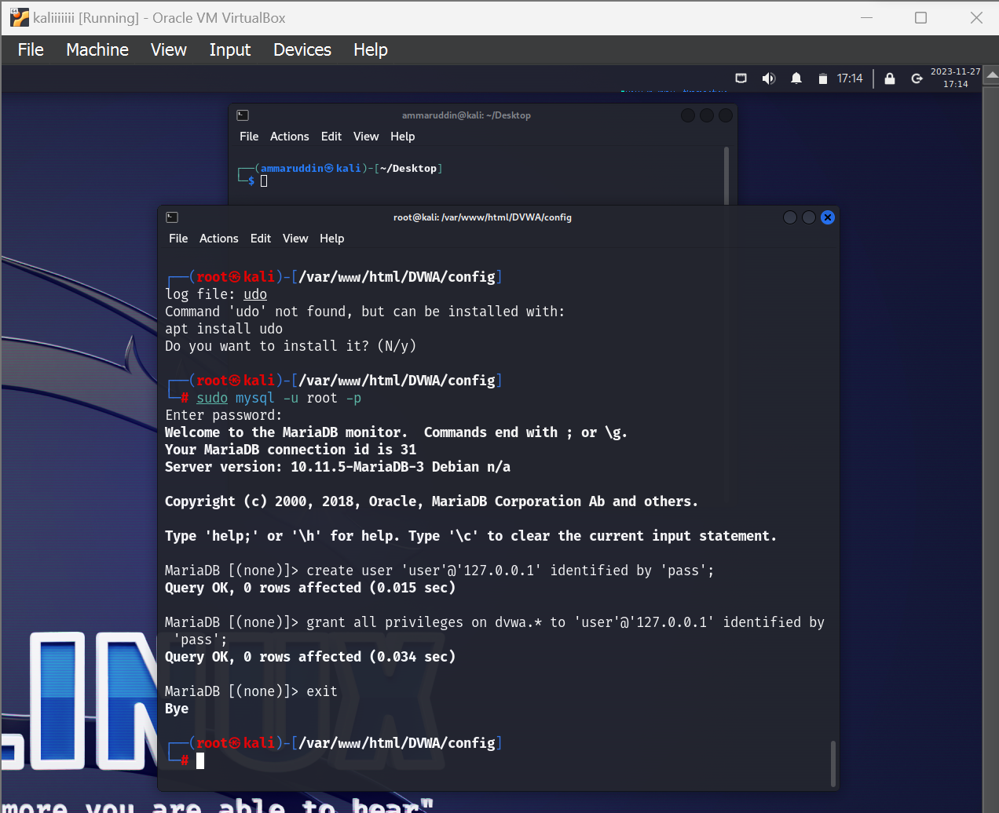

Updating php file

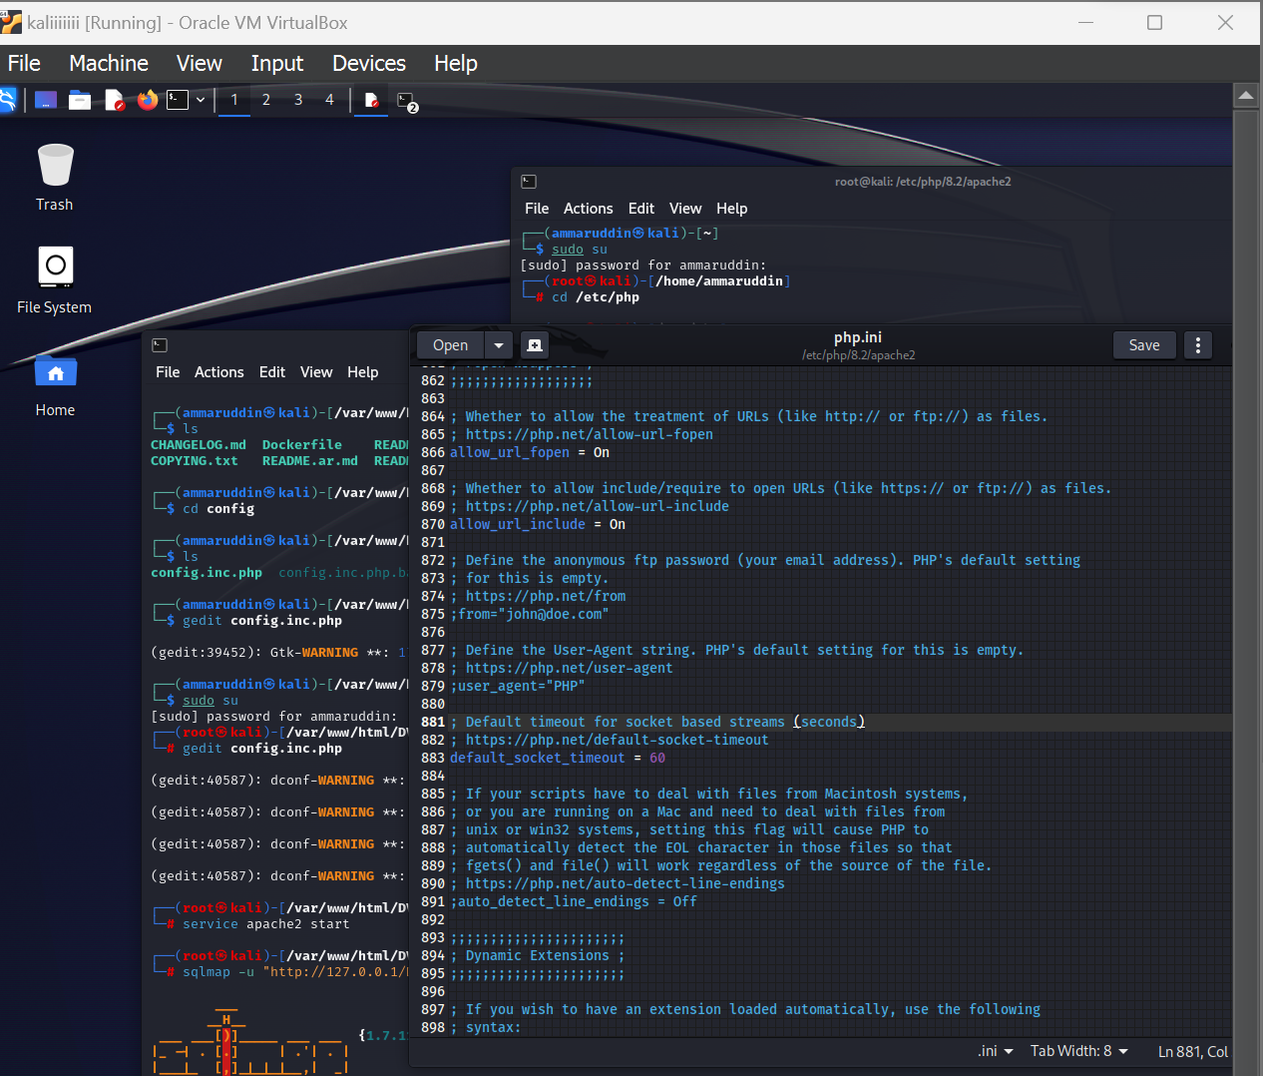

Apache2 running 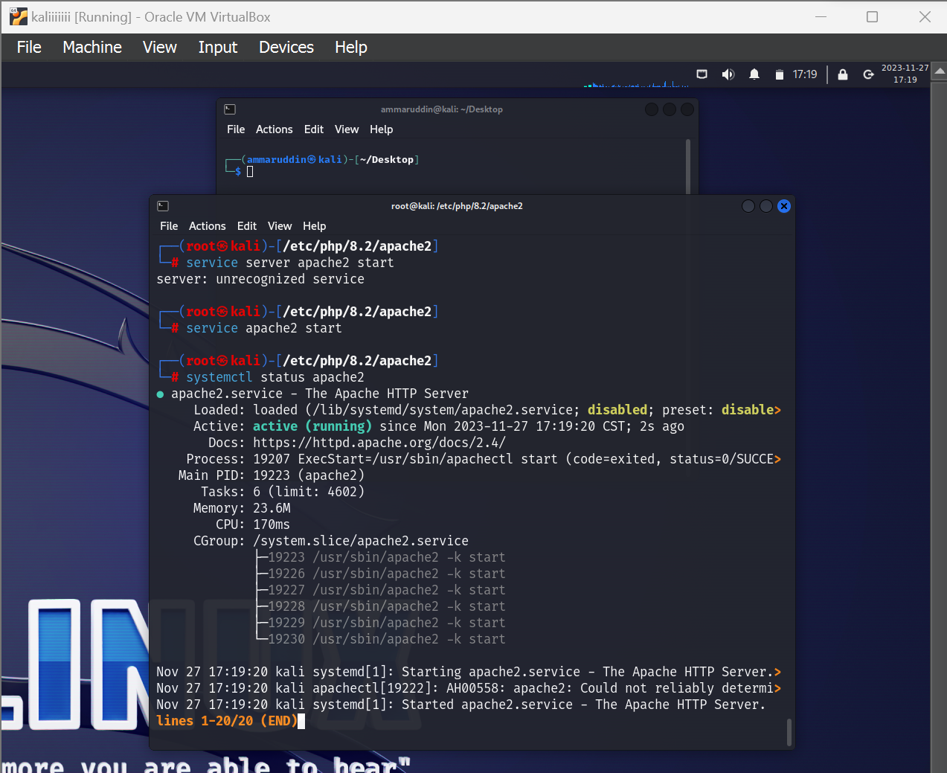

Dvwa login page

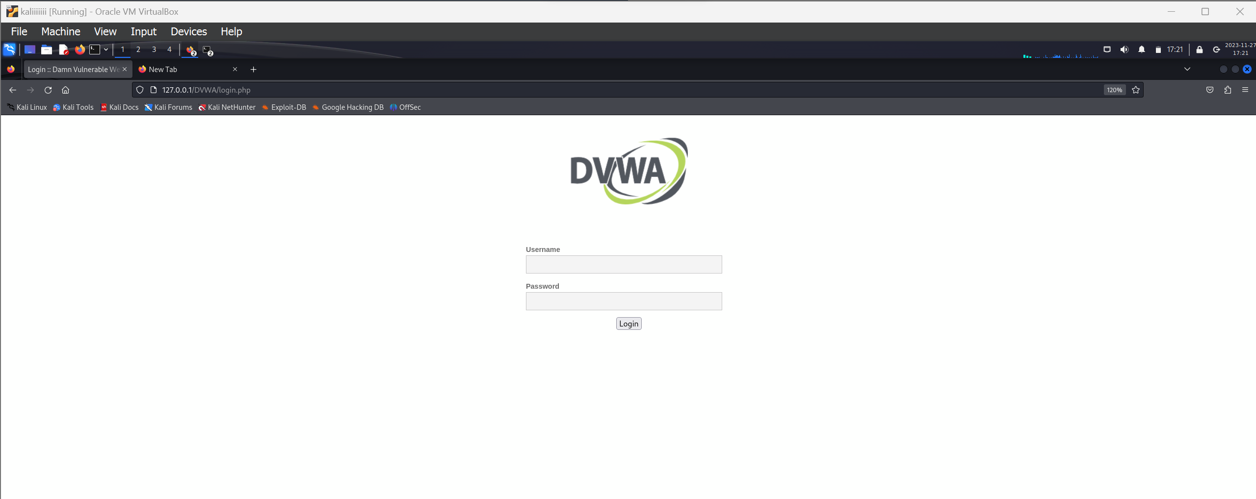

Adjusting the DVWA's Security Setting to 'Low':

With this adjustment, the DVWA is now set up to be more susceptible to vulnerabilities.

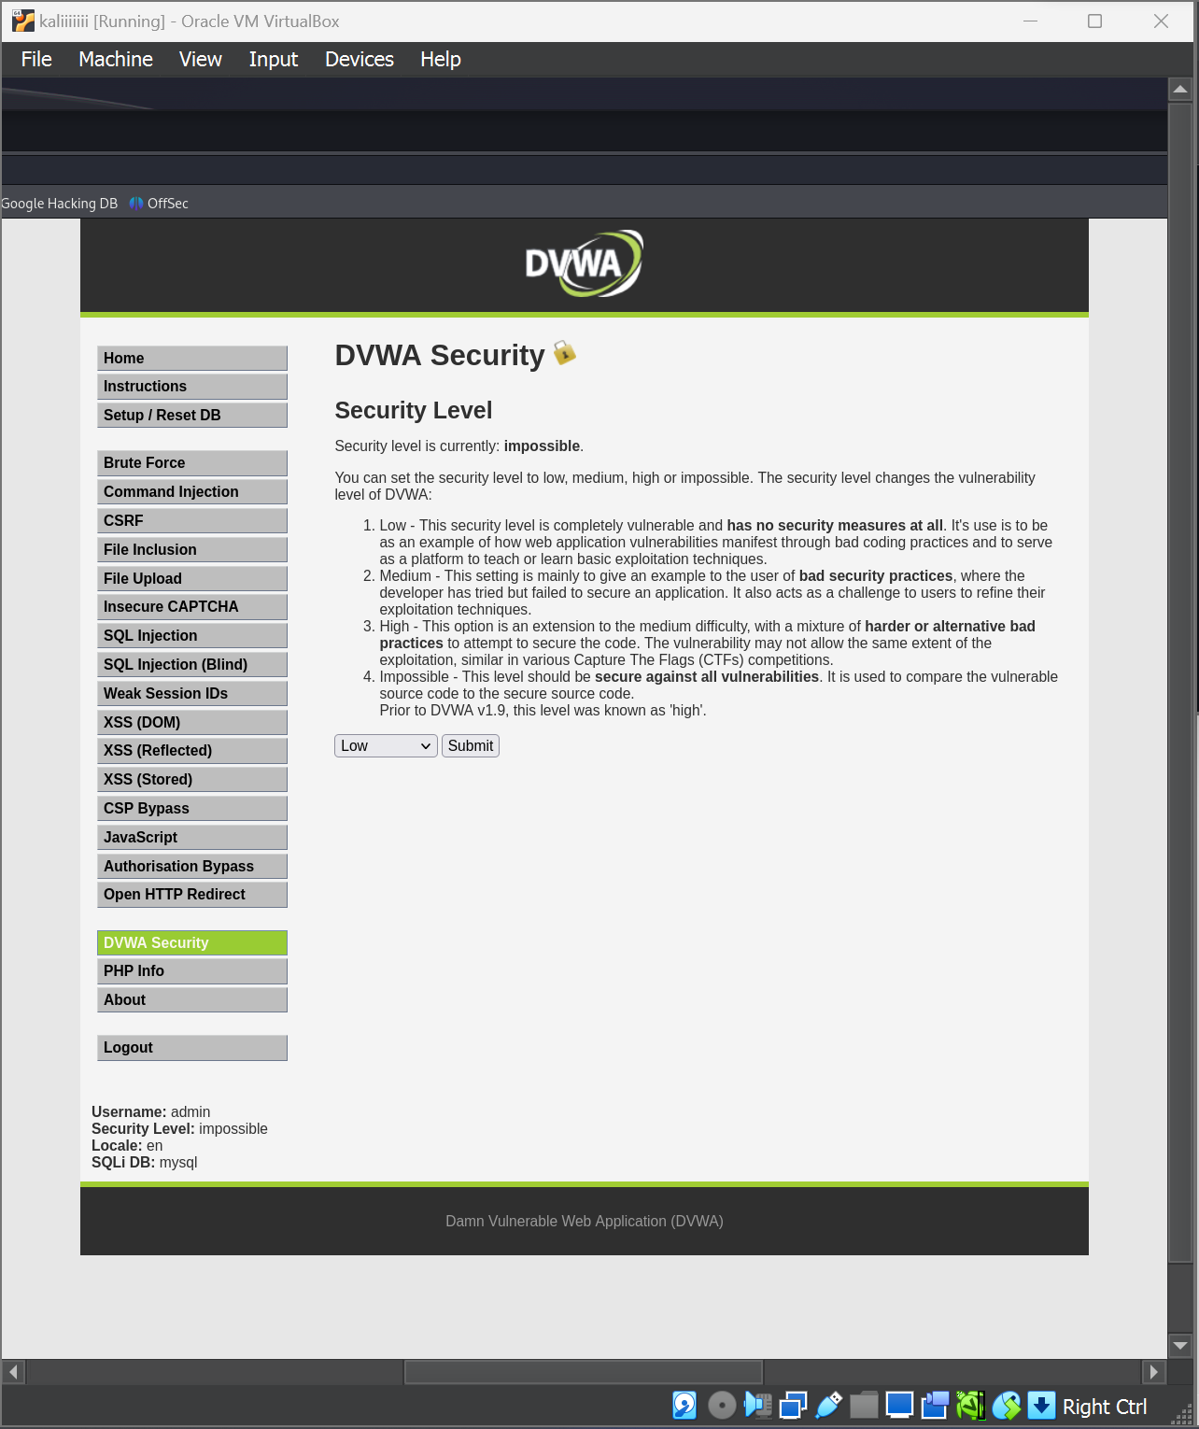

User ID is set to ‘1’.

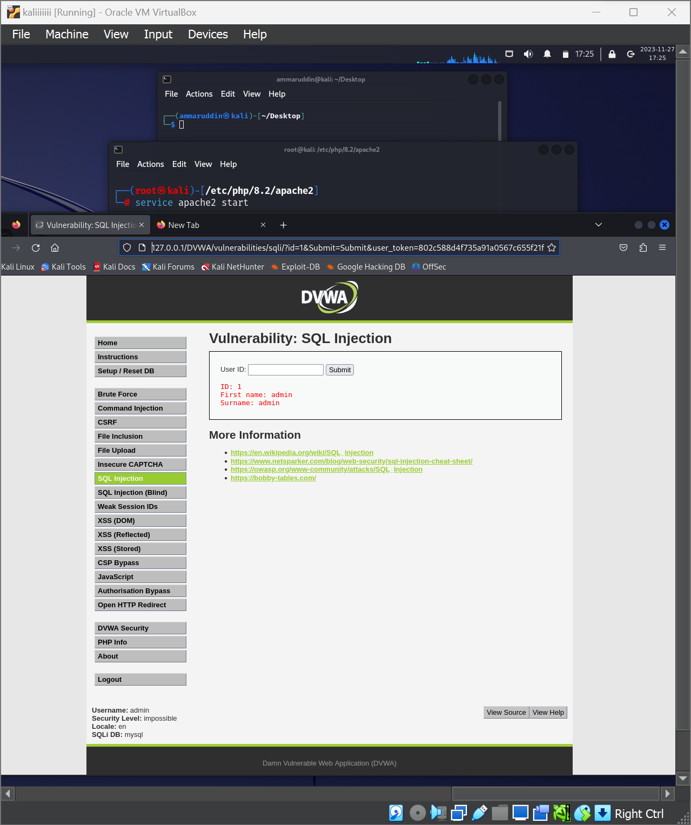

used SQLmap, which is a tool designed to detect and exploit SQL injection vulnerabilities in web applications. I initiated a test against a local web application specified by the URL provided in the command. The --cookie parameter was included to ensure that my session, identified by a specific PHP session ID, was maintained throughout the process.

SQLmap automatically recognized the database management system (DBMS) as MySQL. Leveraging SQLmap's powerful detection capabilities, I instructed the tool to enumerate the database names using the -D flag and it successfully retrieved the database names. The information schema, which is a default schema containing the informational data about the database, was among the fetched data.

The data fetched by SQLmap was logged into text files in the specified directory, allowing me to review the results and determine the next steps in my security testing. The commands I used included several flags like --batch and --threads, which automated the decision-making process and optimized the speed of the attack.

Low dbs

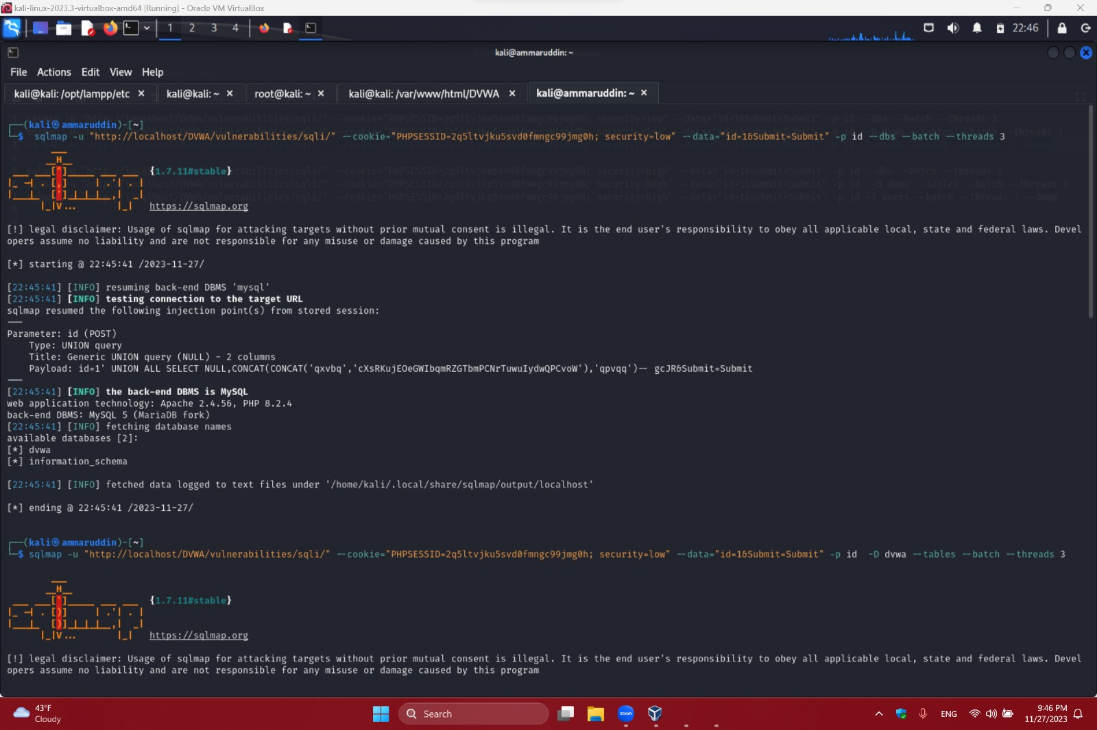

Tables

Using the above command, the list of tables from our database ‘dvwa’ has been extracted:

1.guestbook

2.users

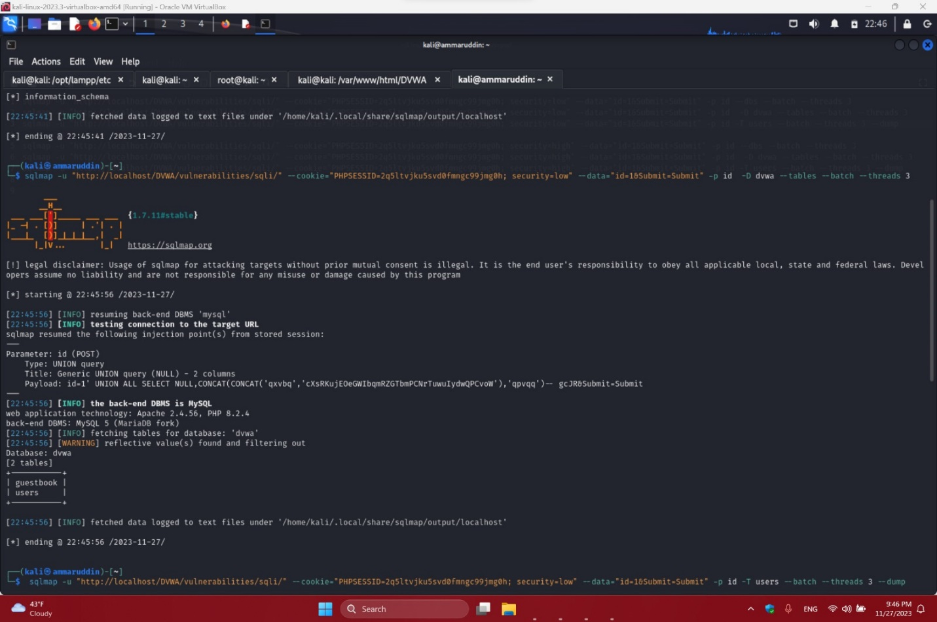

Table dump

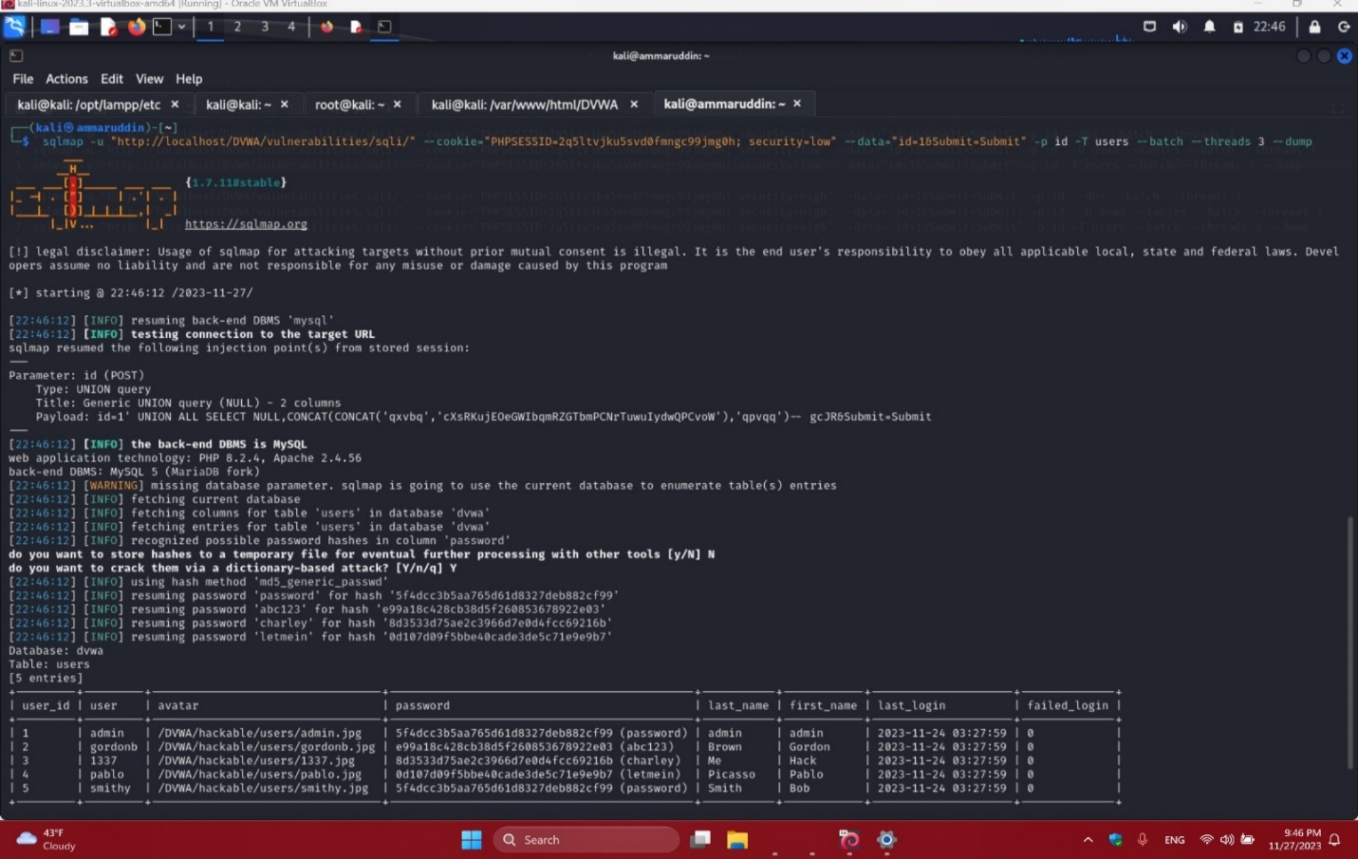

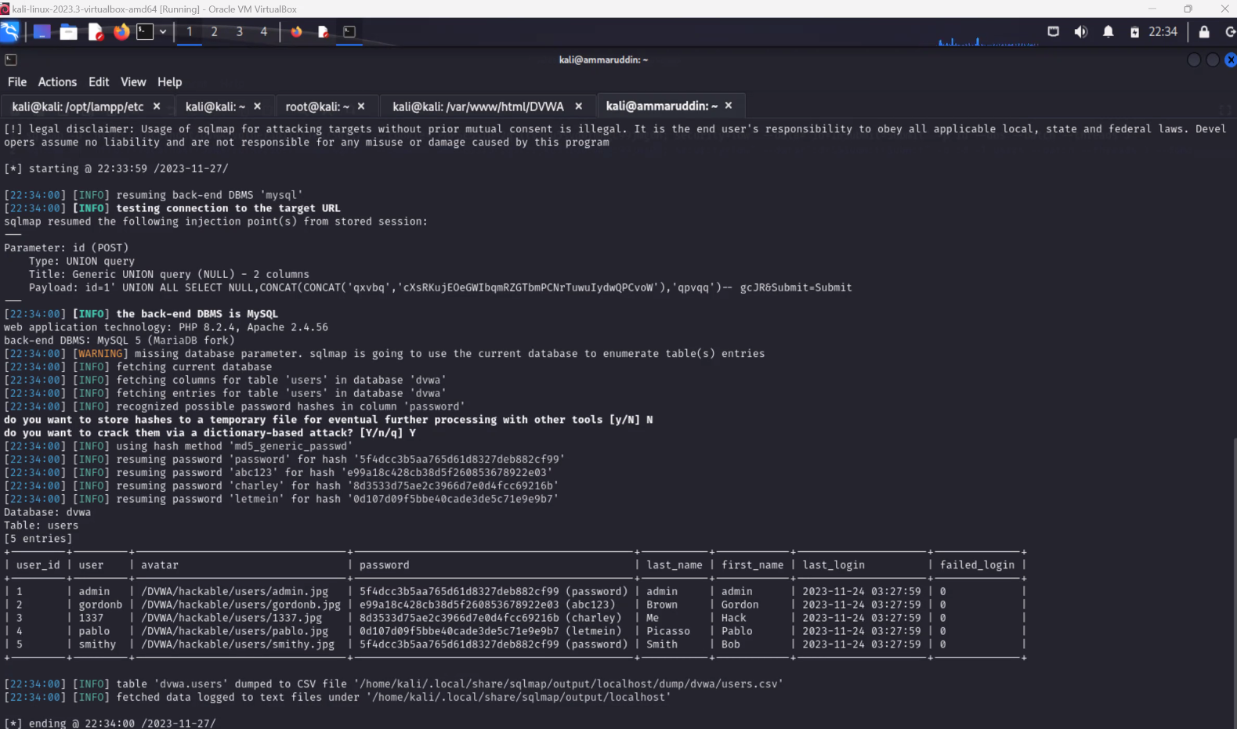

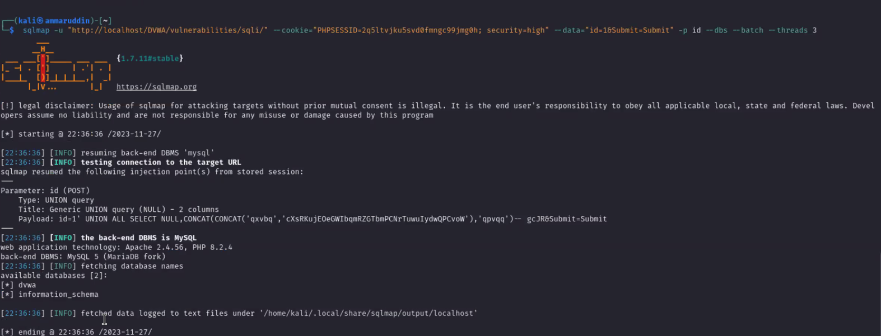

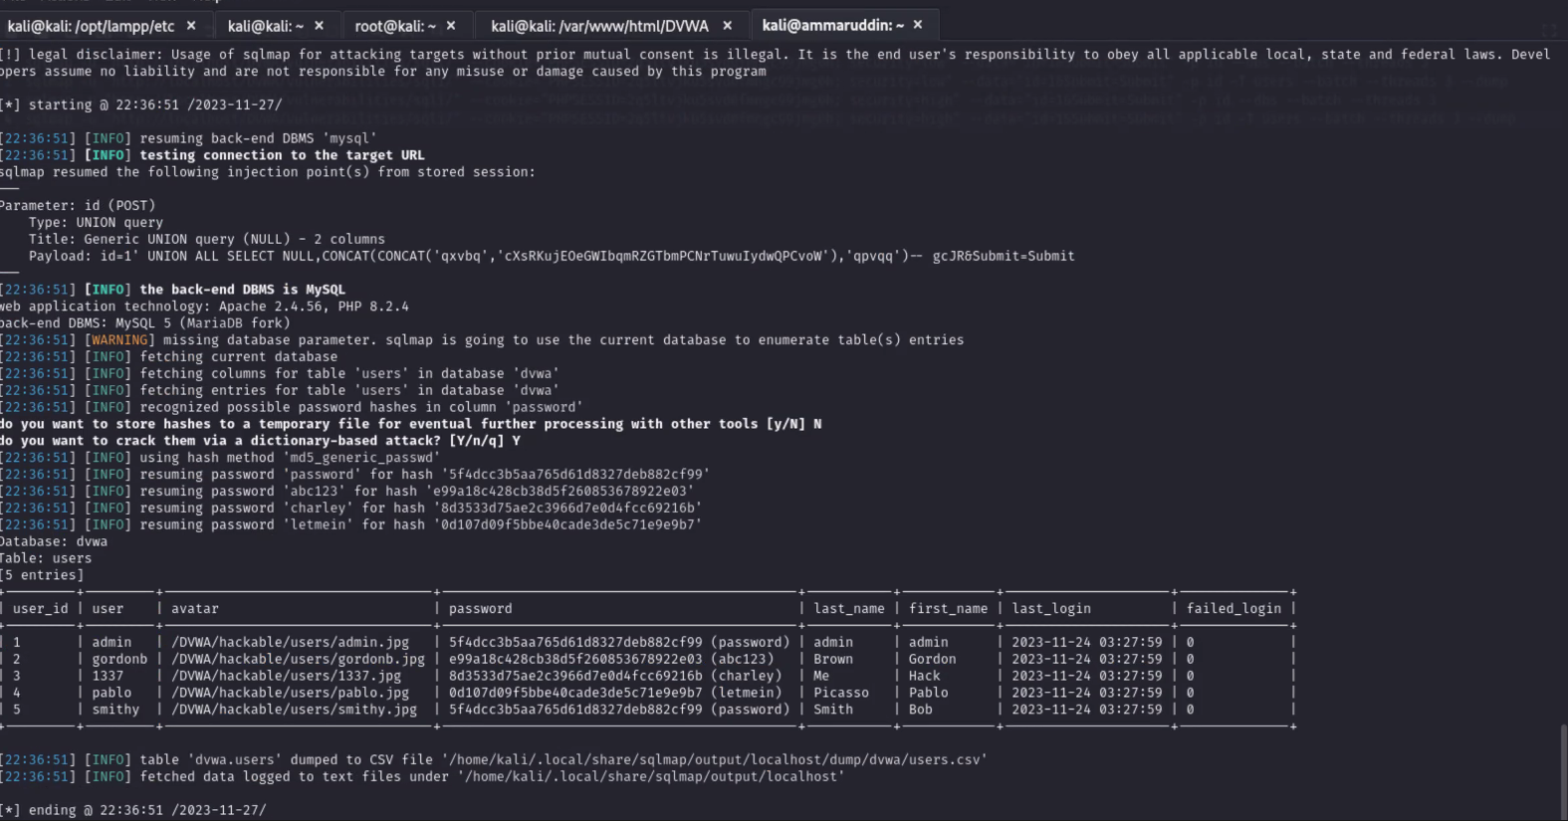

Chosen gordonb from the table

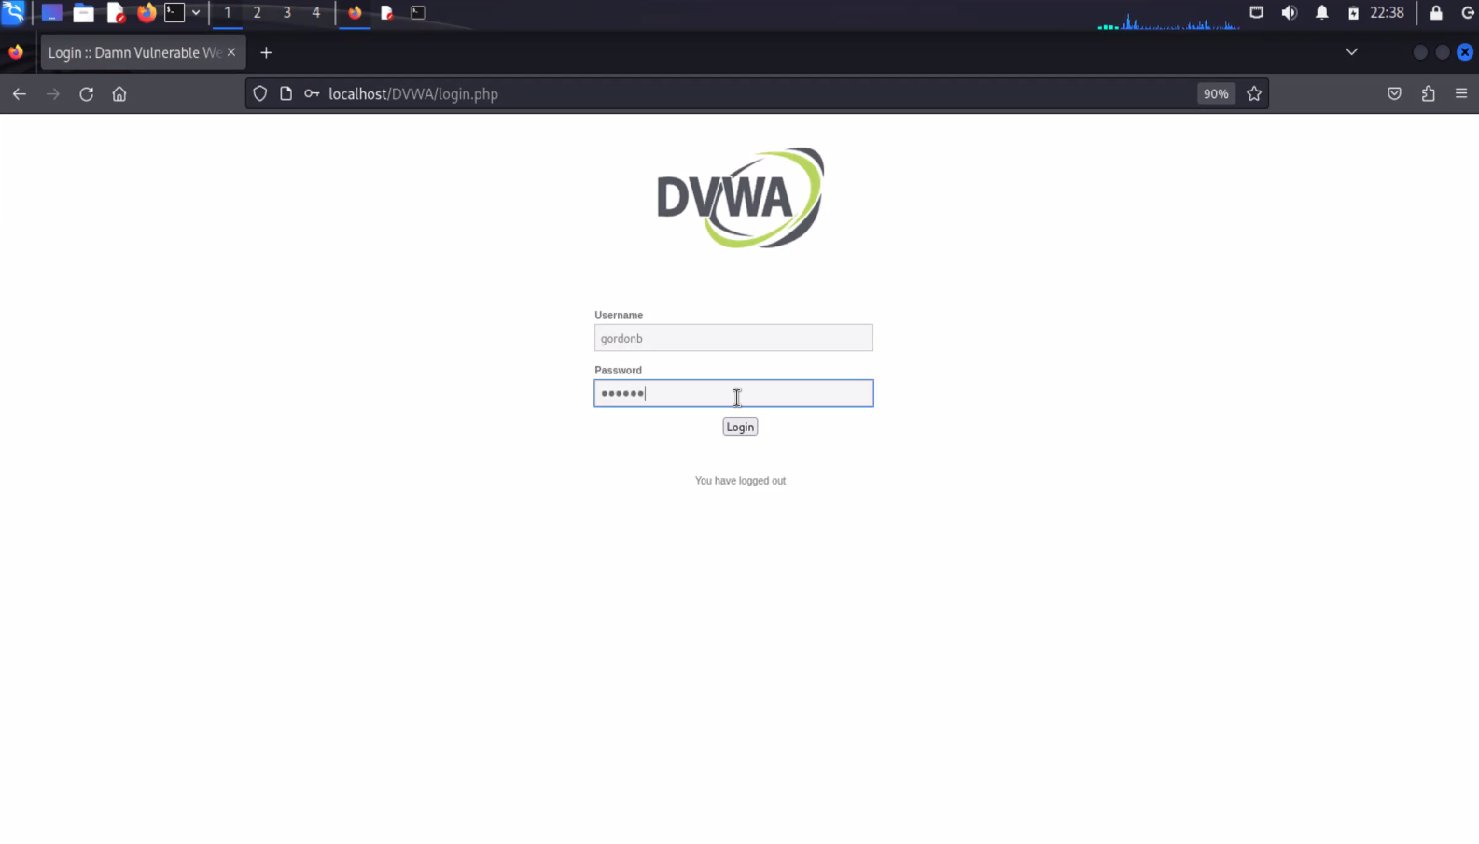

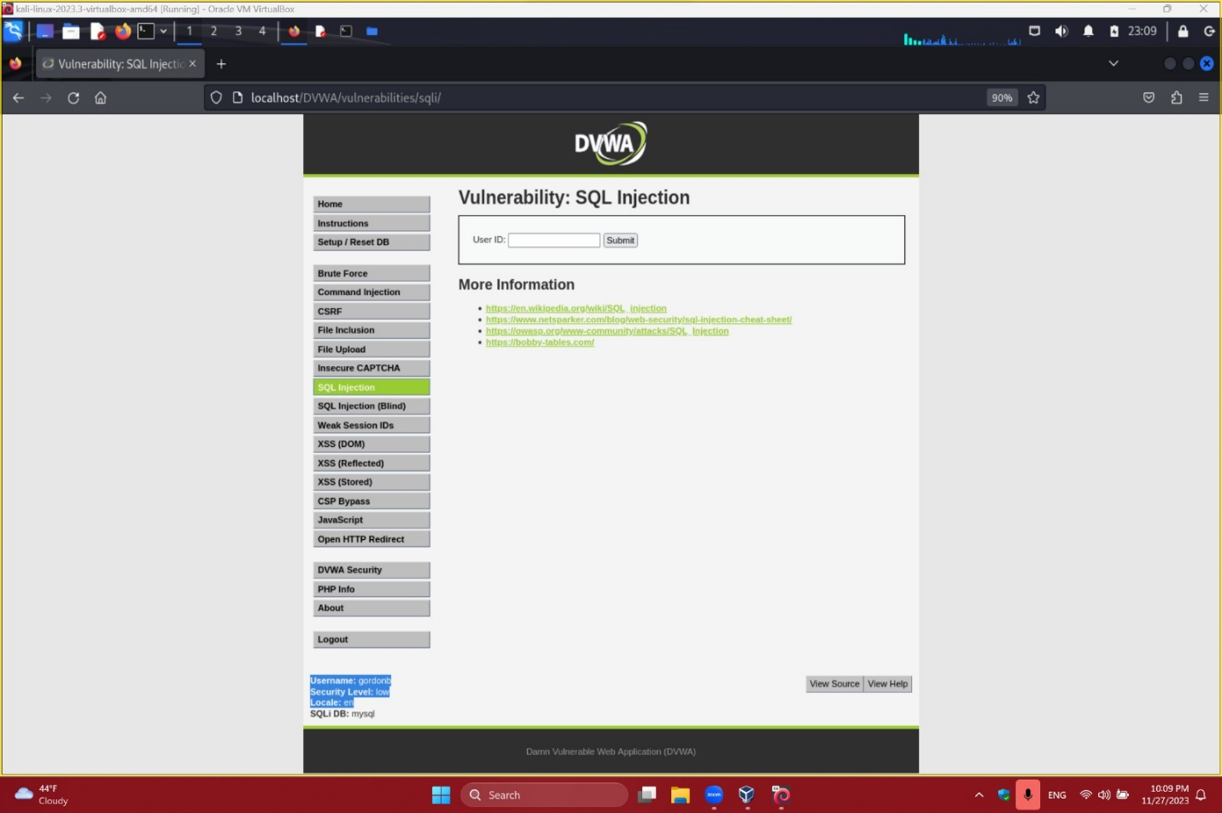

Part B

MEDIUM

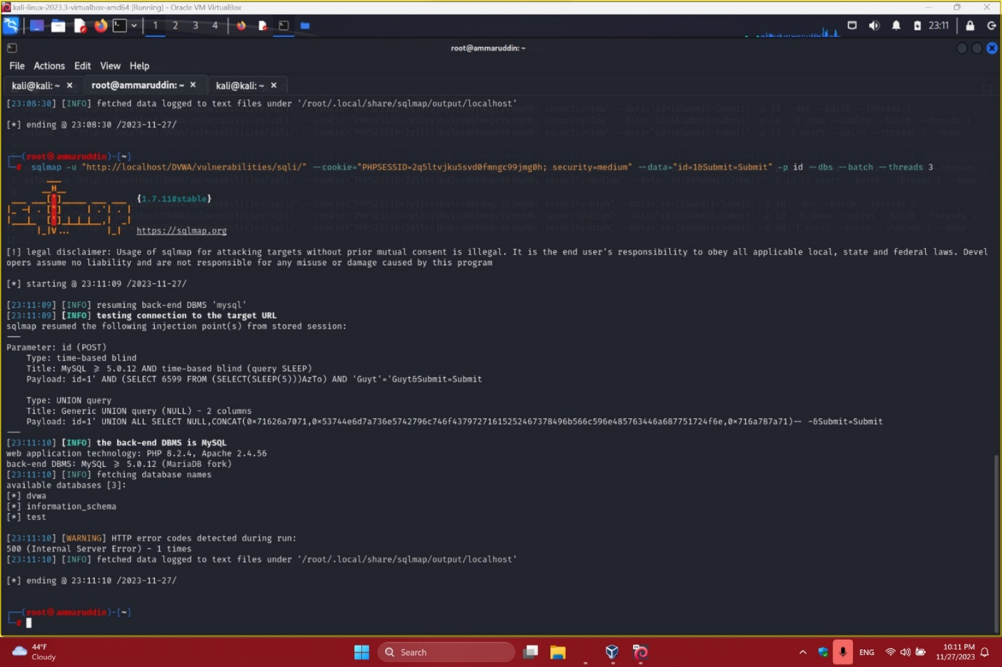

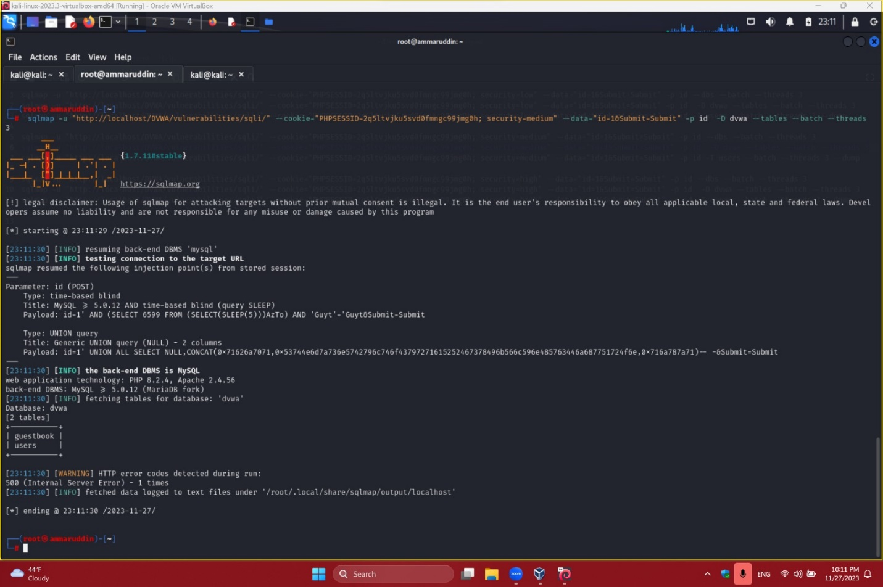

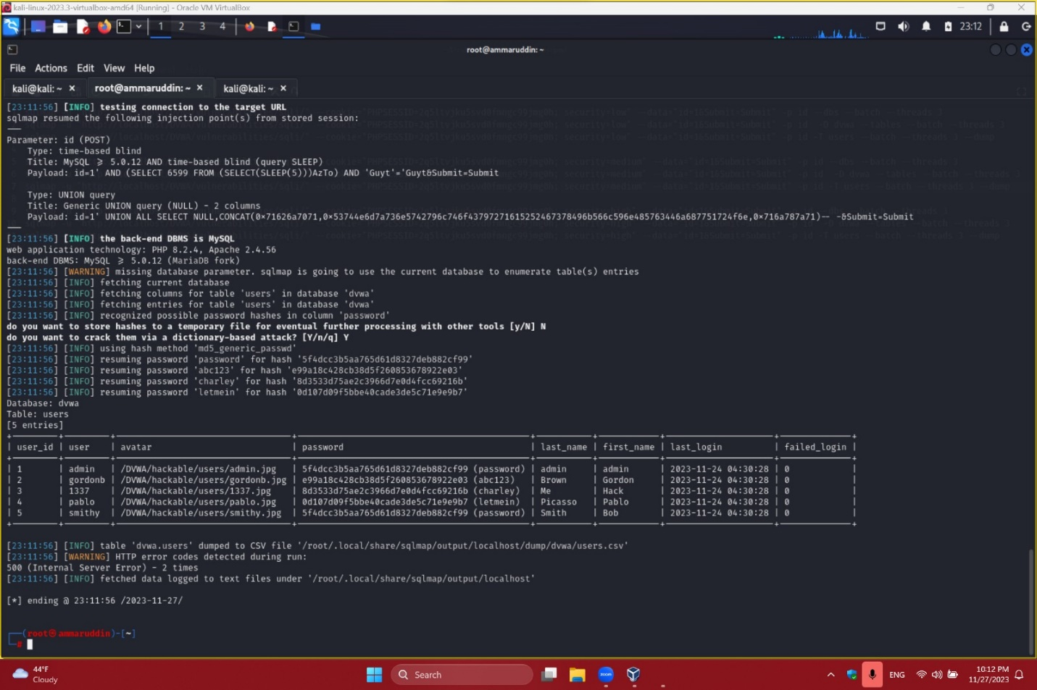

md5 hashes are decrypted during the last command

HIGH

DBS

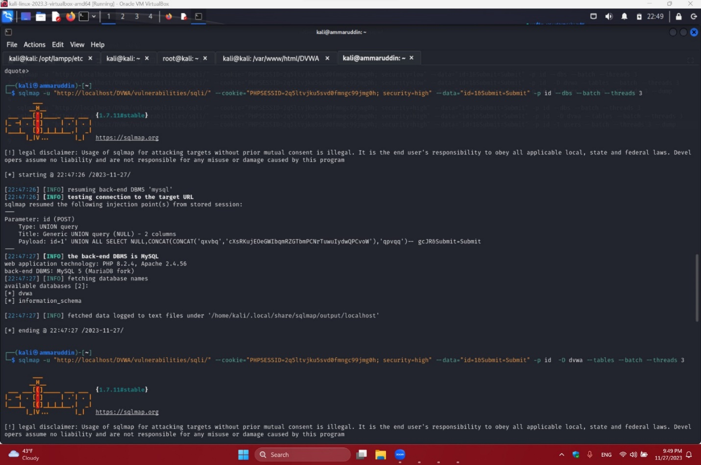

Tables

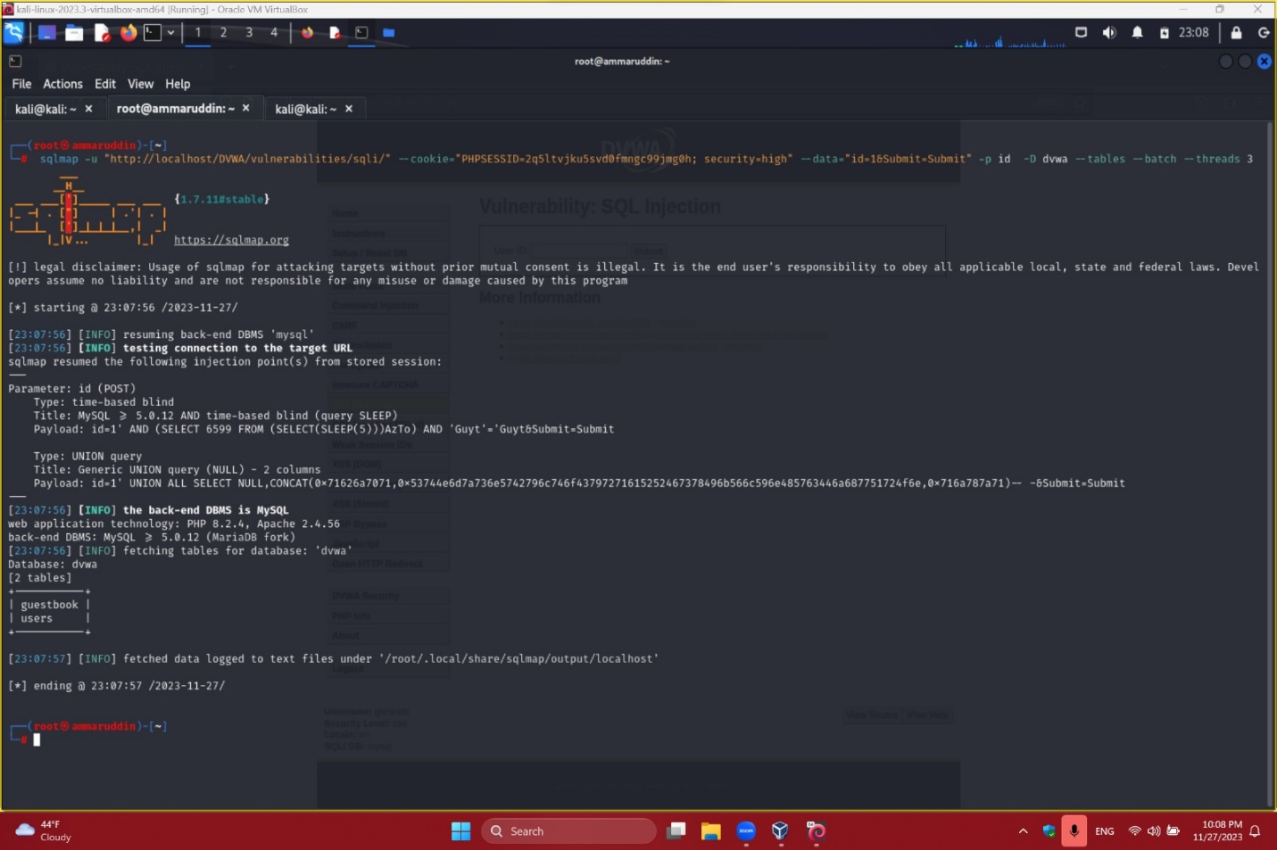

Extract

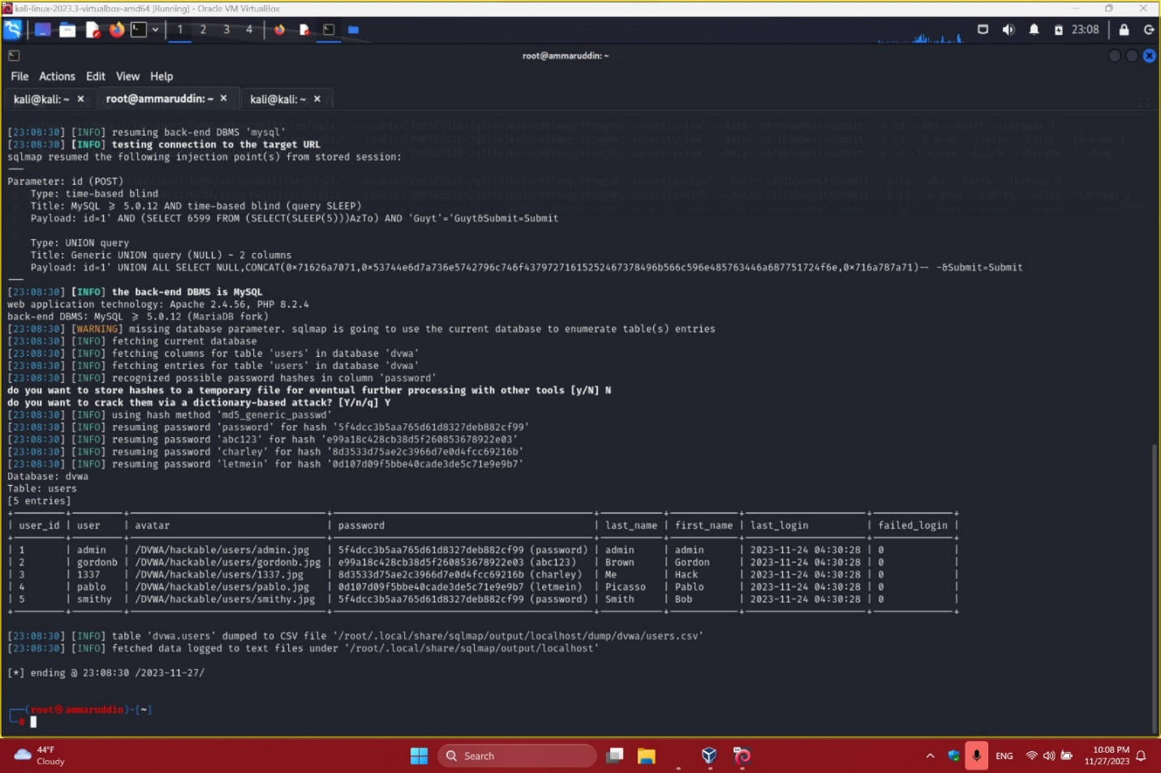

Chosen gordonb from the table



